MSIM 441/541 & ECE 406/506
Computer Graphics & Visualization

Programming Assignment One
Input Analysis Using Histograms
Assigned September 24, Due 12:00 PM October 22

1. Overview
Mathematical visualization has a long history in mathematics and is one of the most important application areas of visualization. Mathematical visualization utilizes 2D or 3D drawings, animations, and interactive user interfaces for understanding and exploring mathematical relationships among different objects. In this programming assignment, you will generate visualizations of two types of mathematical entities: theoretical probability density functions and histograms of existing input data. Both visualizations are used to perform input analysis, one critical and often the first step in many simulation applications.

A simulation can be considered as a black box for generating some outputs based on some inputs. For example, to simulate and improve the operations of a banking center, the inputs can be the time between customer arrivals and the customer service time, and the outputs can be the average customer waiting time and the average number of customers in the waiting line. Usually real data are collected for inputs and are analyzed for fitting a probability distribution to them. For example, exponential distribution is a very good representation of the time between customer arrivals.

A histogram is a graphical representation of the distribution of a set of data. Its generation will be discussed in detail in Section 3 Tasks. You will first generate histograms for the input data and graphical representations of theoretical probability distributions. Then you will adjust the parameters of theoretical distributions so that they match the histograms. The theoretical distribution that best matches the input histogram will be selected and used to generate input data for the simulation.

2. Objectives
Objectives of this programming assignment are divided into two categories: 1) Review and Enhancement; and 2) Learning Outcomes. Review and Enhancement include knowledge and skills that you are supposed to have already known before taking this course and give you an opportunity to enhance them. Learning Outcomes contain the new knowledge and skills you are expected to learn from this assignment.

2.1 Review and Enhancement
- File input/output (I/O)
- Dynamic memory management using new and delete in C++
- String operations using stringstream class
- Generate functions (or classes) in C++.
- Compute minimum and maximum of a set of data.
- Program debugging techniques

2.2 Learning Outcomes
- Generate histograms for input data.
- Understand normal and exponential distributions.
- Generate 2D graphs of functions of one or more variables.
- Use of different types of OpenGL geometric primitives.
- Automatically determine the bounds for world to be visualized.
- Automatically determine the bounds for x and y axes.
- Generate interactive visualization programs that contain menus and respond to keyboard and mouse inputs.
- Generate annotations
- Proper selection of colors for visualization
- Understanding and use of at least the following OpenGL related concepts.
  - GL_LINES
  - GL_LINE_STRIP
  - glRasterPos2f()
  - glWindowPos2i()
  - glutDisplayFunc()
  - glutKeyboardFunc()
  - glutSpecialFunc()
  - glutReshapeFunc()
  - glMatrixMode()
  - glLoadIdentity()
  - gluOrtho2D()
  - glutPostRedisplay()
  - glutCreateMenu()
  - glutAddMenuEntry()
  - glutAddSubMenu()
  - glutBitmapCharacter()

3. Tasks
3.1Reading Input Data
The input files contain the input data to be used in this assignment and are in ASCII format (i.e., text). The first line of the file contains the number of data points in the file and each subsequent line contains one data point. This project provides two sample files: normal.dat and expo.dat. Write code to find the number of data points, minimum, and maximum for both files.

3.2 Probability Density Histogram
A histogram is a graphical representation of the distribution of a set of data using a group of rectangles. In particular, you will generate probability density histograms, with the vertical axis representing probability density. The range of data (i.e., maximum  minimum) is divided into a number of intervals (or bins). The area of the rectangle for each interval represents the probability of data points (or observations) falling in that interval. The height of each rectangle is the probability density for the corresponding interval. Develop data structures and write code for computing histograms of different input files (the number of intervals should be variable among three values: 30, 40, and 50).

The next step is to generate the graphical representations of histograms. First you need to determine the bounds of the world to be visualized. Since this assignment only involves 2D graphics, you only need to determine the limits along x and y directions. In this assignment, x axis represents data values (from the input files) and y axis represents the probability densities (always non-negative). Based on what have been discussed so far, determine proper bounds for x and y directions. Note that you probably need some margins for your visualization, i.e., you don’t want your visualizations to fill the entire OpenGL window. Generate the histograms and the input files and the number of intervals should be selectable via a pop-up menu. Also draw x and y axes and create annotations similar to that are shown in Figure 1. Note: you need to draw everything in world coordinates, not in screen coordinates. Use gluOrtho2D() to map the world to your screen.

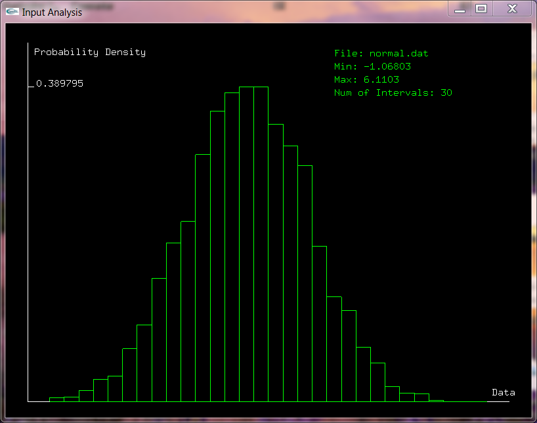
Figure 1. The histogram for normal.dat
3.3 Probability Density Functions
A probability density function (pdf) of a continuous random variable describes the relative likelihood for the random variable to take on a given value. The probability of the random variable being within a particular range is computed by the integral of the pdf over that range. This assignment involves two popular distributions: normal distribution and exponential distribution.

The pdf for the normal distribution is:
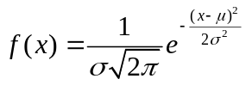,
where x is the random variable, is the mean or expectation of the distribution and is the standard deviation. The normal distribution is commonly used to model many phenomena and extremely useful because of the central limit theorem, which states that the mean of many random variables from the same distribution is approximately normally distributed.

The pdf for the exponential distribution is:
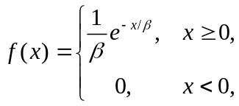
where x is the random variable and is the scale parameter and is also the mean or expectation of the distribution. The exponential distribution describes the time between events in a Poisson process, such as customer arrival events at a restaurant.

Generate visualizations for the normal and exponential distributions using GL_LINE_STRIP. The parameter should be changeable using Left and Right arrow keys (Left: decrease; Right: increase) and the parameters and should be changeable using Up and Down arrow keys (Down: decrease; Up: increase). The type of distribution and the step size for changing parameters should be selectable via a pop up menu. The parameter step size should be selectable among 0.01, 0.02, and 0.05. Also add proper annotations. These features are illustrated in Figures 2 and 3. Again, you need to draw everything in world coordinates, not in screen coordinates.
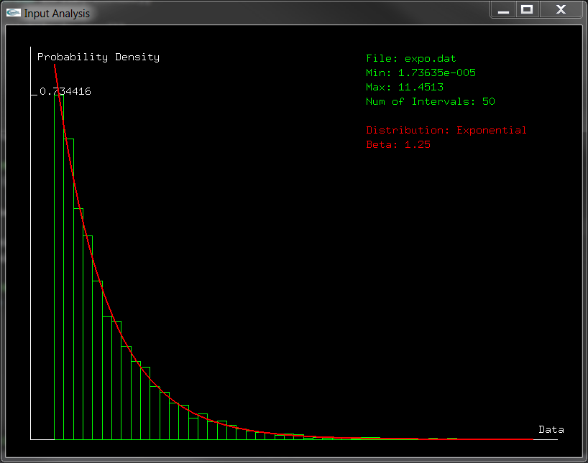
Figure 2 Exponential distribution (expo.dat)

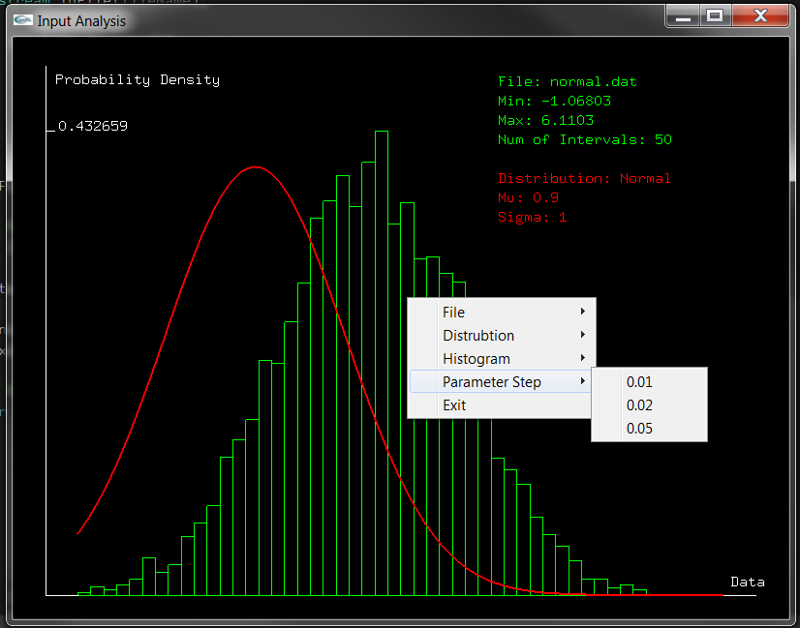
Figure 3. Parameter size selection

3.3 Input Analysis (Matching Histogram and Probability Density Function)
In addition to the files normal.dat (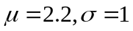) and expo.dat (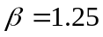) you have used to this point, you need to select at least two more files from the 20 data files provided in this assignment based on the following rules.
- The first file number = Your First Name Initial % 10 + 1
- The second file number = Your Last Name Initial % 10 + 11
Generate histograms for both data sets and determine their corresponding theoretical distributions via visual comparison. Note that for all data files, the parameter ranges are: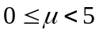,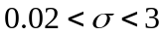, and 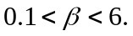

3.4 Visual Perception
Try different colors for different objects in your visualization. Compare them and determine the best color scheme for this assignment and state your reasons. Include screen captures for different color schemes in your report, but your submission only needs to include the code for the best color scheme you select.

3.5 Evaluation Criteria (Optional for MSIM 441/ECE 406; Required for MSIM 541/ECE 506)
The histograms and theoretical pdfs are compared visually to determine whether they match each other. It certainly takes time to find the best match and sometimes it is hard to decide which theoretical pdf is a closer match to the histogram. Thus, it is desirable to develop automated methods to determine the best match or fit between them.

Propose a metric that measures the difference between a histogram and a pdf. Describe its computation in detail, and if necessary, provide associated mathematical formulations (equations).

Extra credit (3 points): Implement the metric you propose above in your program and display it in the annotation area.

4. Coding (60 points)
You can use either C or C++ for this assignment, but C++ is recommended. Exercise good coding practices, such as naming variables meaningfully and properly, including comments of key classes, variables, functions, and code segments, and using indentations and proper spacing between tokens (e.g., variables, operators). Points will be deducted for lack of comments or bad formatting (e.g., no indentation or large blank spaces in the code). The following is the grade allocation for different tasks or functionalities of your program.
- Histogram: 20 points
- PDF: 20 points
- Annotation: 10 points
- Interactivity: 10 points (e.g., automatic determination of world size, proper coloring, smooth transition between different functions and parameter settings)

Your menu structure should contain at least the following items.
- File
  - normal.dat
  - expo.dat
  - your file 1
  - your file 2
- Distribution
  - Normal
  - Exponential
- Histogram
  - 30
  - 40
  - 50
- Parameter Step
  - 0.01
  - 0.02
  - 0.05
- Other items you want to include (optional)
- Exit

5. Report (40 points)
The report should contain at least the following sections and use the same formatting in this assignment description or other professional formats. Points will be deducted for improper formatting.
- Introduction (5 points): overview of the assignment, such as background, objectives, and brief summary of what you have done for this assignment. Don’t repeat the assignment description verbatim.
- Program Design (15 points)
You will use doxygen to generate the documentation (help) file for your code. You need to generate documentation for all classes, class variables, class methods, and internal implementations of critical methods, for all types of access modifiers (public, protected, and private). Your documentation should include source code, class diagrams, call graphs, and caller graphs. Your documentation should be contained in a single .chm file.
- Results (15 points): Describe what you have done for each task specified in Section 3: Tasks. Include results and necessary screen captures for each task. Answer the questions in the task if any.
- Conclusion and Discussion (5 points): Discuss your accomplishments, learning outcomes, and difficulties and how you can do better for this assignment. Feel free to suggest other ideas for this assignment and discuss other relevant topics (e.g., the numbers of hours you have spent on this assignment).

6. Deliverables
Submit your report and your entire Visual Studio solution with the data files you used. Compress everything into one file and submit it to Blackboard.

